Pepper, the Moody Mood Lamp, a Colour Changing and Morphing Lamp for exploring Artificial Life and Intuitive Reaction to Voice Through Deep Learning
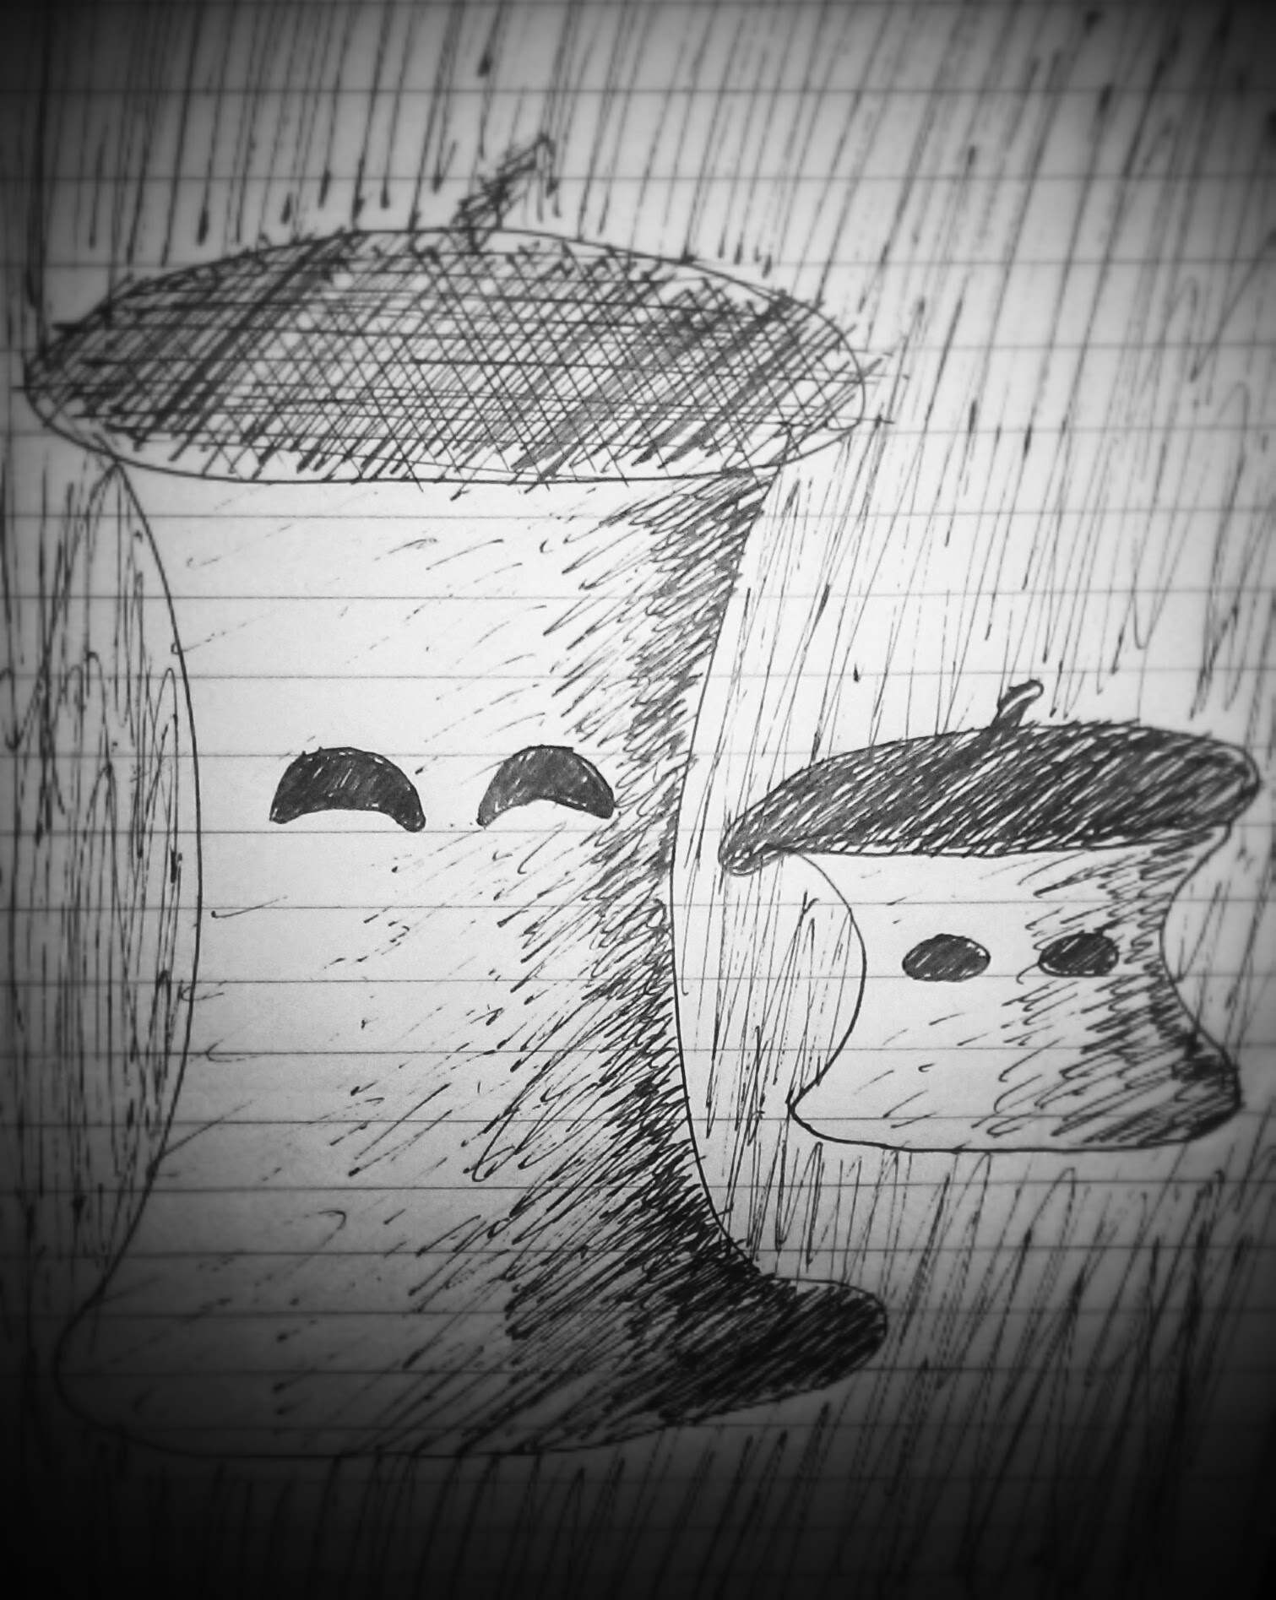
Objective:
Obtain understanding of and experience with deep learning algorithms, embodiment, i.e. the subsumption architecture, and artificial life through developing a small colour changing and morphing mood lamp capable of reacting to different tones of voice, e.g. angry or sweet.

Motivation:
Two underlying motivating factors influence this project, creating artificial life and understanding deep learning algorithms. Experience with embodiment and the subsumption architecture is a learning choice opposed by painstakingly thought out complicated final state machines. Simplicity and evolution is key in this project which fits well with the subsumption ideas. As introduced by Rodney Brooks, embodiment seems to be an effective way of developing complex and robust biological behaviours iteratively from simple components. Deep learning is a popular new machine learning approach capable of achieving some of the most accurate and general classification results of contemporary techniques. What better way to learn about these kind of algorithms than to implement them on a robot, first using pre-trained knowledge/rules, but especially when it itself should learn and improve automatically from data it collects during its operation. The other aspect of artificial life is driven by the ever closer realization of intelligent robot entering the world in all of its facets, from industry to companionship [1]. Trying to predict the final form of robots at the turn of this century would be foolish, but exploration of the possibilities of robotics of our own present time could most certainly be beneficial and interesting none the less. The specific strand of research involving animal/human-like behaviours and means of communication is deemed relevant due to the fact that we inescapably are humans with behaviours to fit. There are surprisingly many dimensions to our own interaction with each other, all of which come natural to us, e.g. reinforcing speech with hand gestures or raising an eyebrow to influence the meaning of a certain statement. Utilizing these often pseudo-subconscious gestures have the potential to ease interaction with computers and robots significantly. An extreme extrapolation of this idea is to create artificial life with behaviours similar to our own in order to achieve both optimal communication, but not least a new species to interact with.

Learning Goals:

Project priciples and formalities:
- Design principles:
Pepper is supposed to end up as a companion for a human and should further on be as portable as possible, so she could be brought along anywhere in a bag. Therefore her design principles are light weight materials, low profile features and collapsibility with easy reassembly.

- Agile development:
This project will incorporate agile development methodologies. The main consequence of this is that the robot will evolve several times during the project, instead of only ending up partly finished at the deadline like it too often happens with similar projects.

- Success criteria and documentation:
State 3 and possibly state 4 will be attempted achieved within this project. Changes and reductions to states will occur. The latest state of the robot will be documented in an Scientific Article, based on empirical measurements of tone-of-voice classifier performance and overall appearance and acceptance of system, possibly based on small user reaction survey.

Task definitions and descriptions:

State 1:
- Create a colour changing lamp fading based on sound intensity using some white cloth, a wire frame, a RGB LED, an Arduino Duemilanove and a microphone.
State 2:
- Research choice between raspberry pi and android smartphone for computational unit. Implement choice.
- Minor literary review of artificial emotion systems and deep learning.
- Incorporate simple eyes made out of two small LED matricies to gain anthropomorphic features powerful in communicating emotion to humans
- Implement changing colour/mood according to internal mood function. Subsumption based software architecture.
- Record or obtain simple data set for a few different tones of voice.
- Implement simplest deep learning neural network to try to classify angry tone of voice from sweet.
State 3:
- Optimize deep learning classifier and add classes.
- Expand internal mood function to include several external factors, e.g. ambient light or average noise intensity.
- Utilize directional hearing to locate the source of voice stimulation.
- Install a servo to have the eyes rotate around the cylindrical body to simulate directional gazes.

This project builds upon the Pepper robot platform. Pepper consists of simple colour and shape changing eyes on a smart phone screen, body made of white cloth over a simple rigid skeleton with 1DOF movement, a powerful RGB LED for lighting. It is capable recognizing difference between positive and negative tone of voice using machine learning and reacts accordingly by changing its own mood, expressed by colour and eye shape.

State 4
- Build a simple differentially steered base with large wheels to enable following the sound source.
- Implement more advanced deep learning classifier.
- Implement mood function as a learning algorithm that develops
State 5:
- Include sensor fusion with sensors like acceleration, ambient light, time of day etc.
- Incorporate simple actuation of the structure using LocoKit to gain the advantage of embodied communication through morphing, e.g. decreased size when scared or sad.
- Implement dense led matrix across entire skin to enable charmeleon like color behaviours, including patterns or low resolution video clips.
- Enable internet connectivity and incorporate google now functionality in order to move in the direction of personal assistant.
- Implement sunset wakeup alarm functionality, for naturally pleasant mornings.

Time schedule:
- Complete state 1 by end of week 39
- Complete state 2 by presentation in week 44
- Present progress week 44
- Complete state 3 by week 48
- Focus on documentation and performance measurements during week 49 and 50.
- Deadline for documentation 15th of December i.e. primo week 51
- Presentation of completed project to class in week 1

References:
[1] Shibata, Takanori, (2004), "An Overview of Human Interactive Robots for
Psychological Enrichment." Proceedings of the IEEE. 91(11
[2] Brook, Rodney A., (1990), “Elephants don't play chess” Robotics and Autonomous Systems,

